

DLD Lab-07
Magnitude Comparator


NATIONAL UNIVERSTIY OF COMPUTER AND EMERGING SCIENCES, FAST- Peshawar Campus
Department Of Computer Science
EL 1005– Digital Logic Design-Lab
SEMESTER SPRING 2026

Contents
1. Objectives: 2
2. Digital Comparator 2
3. Magnitude Comparator 3
4. 1-Bit Magnitude Comparator 3
5. 2-Bit Magnitude Comparator 6
6. How to design a 4–bit comparator? 9
7. Applications of Comparators 11
8. Code converters 12
9. BCD, Excess-3 code 12
10. Binary, BCD, Excess-3 code 13
11. Students Task 15

Objectives:
Magnitude Comparator
- Design and implement the circuitry for 1-bit magnitude comparator.
- Design and implement the circuitry for 2-bit magnitude comparator.
- Design and implement the circuitry for 4-bit magnitude comparator
- Truth Table
- K-Map
- Equation
- Circuit Diagram
- Implementation
Code Converters
Design and implement the circuitry for a BCD-to-Excess 3 Code Converter.

Digital Comparator
- It is a combinational (circuit without memory) logic circuit.
- Digital Comparator is used to compare the value of two binary digits.
- There are two types of digital comparator
(i) Identity Comparator
(ii) Magnitude Comparator.
- IDENTITY COMPARATOR:
  - This comparator has only one output terminal for when A=B, either A=B=1 (High) or A=B=0 (Low)
- MAGNITUDE COMPARATOR:
  - This Comparator has three output terminals namely A>B, A=B, A<B. Depending on the result of comparison, one of these output will be high (1)
- Block Diagram of Magnitude Comparator is shown below in Fig. 1

Magnitude Comparator
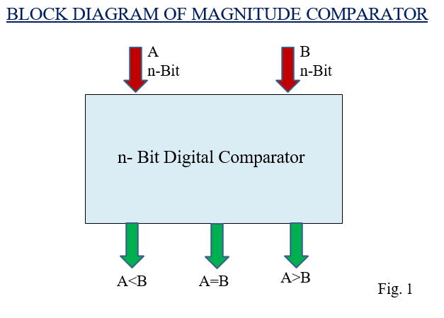

1-Bit Magnitude Comparator
- This magnitude comparator has two inputs A and B and three outputs:
- A<B, A=B and A>B.
- This magnitude comparator compares the two numbers of single bits.
- Truth Table of 1-Bit Comparator
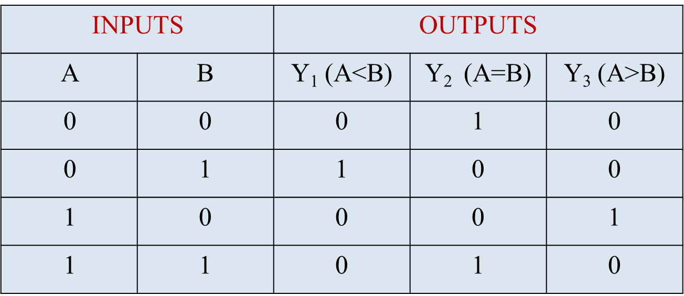

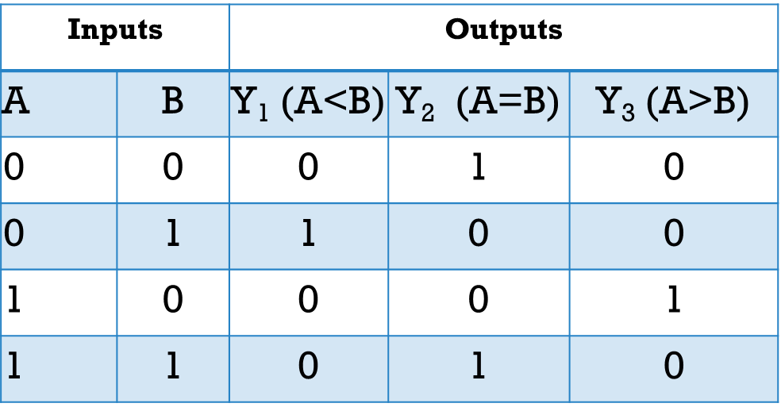

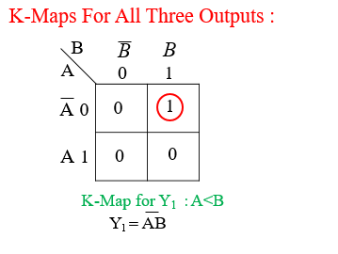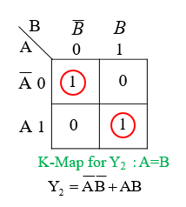
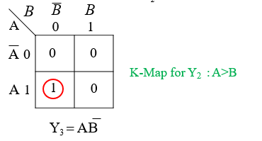
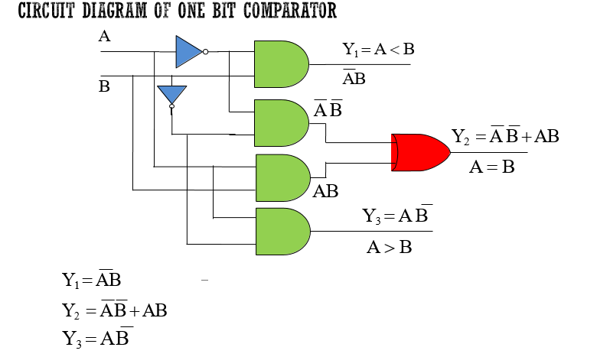
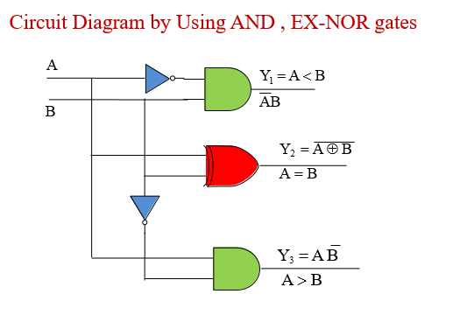

2-Bit Magnitude Comparator
- A comparator which is used to compare two binary numbers each of two
- bits is called a 2-bit magnitude comparator.
- Fig. 2 shows the block diagram of 2-Bit magnitude comparator.
- It has four inputs and three outputs.
- Inputs are A₀ ,A₁,B₀ and B₁ and Outputs are Y₁, Y₂ and Y₃
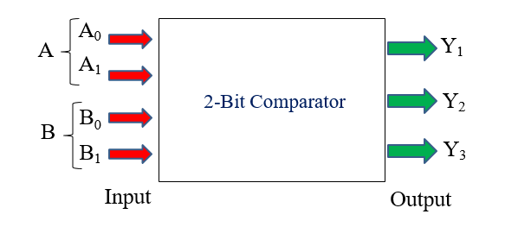
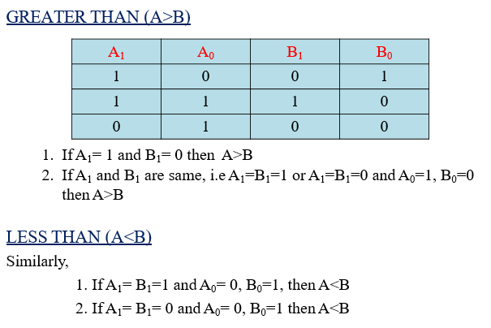

TRUTH TABLE
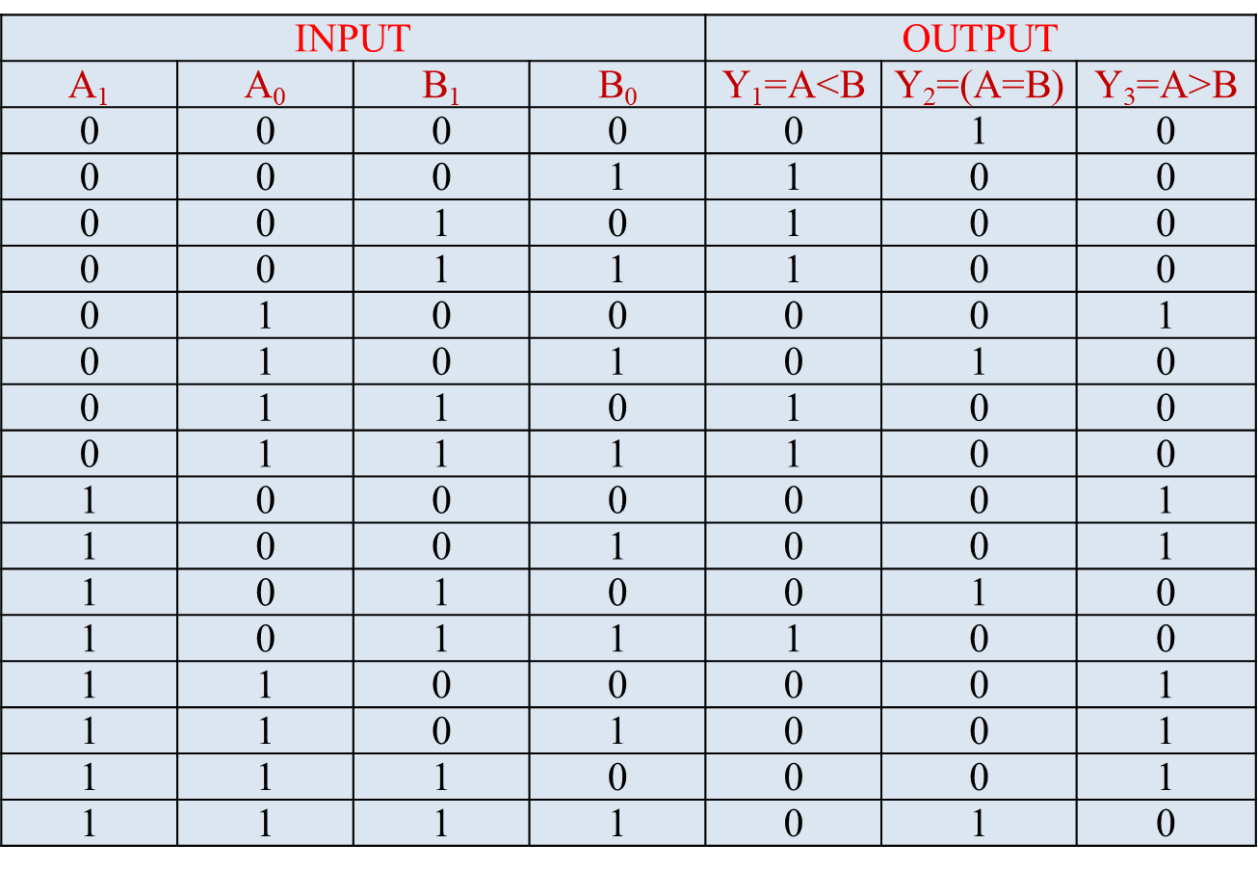

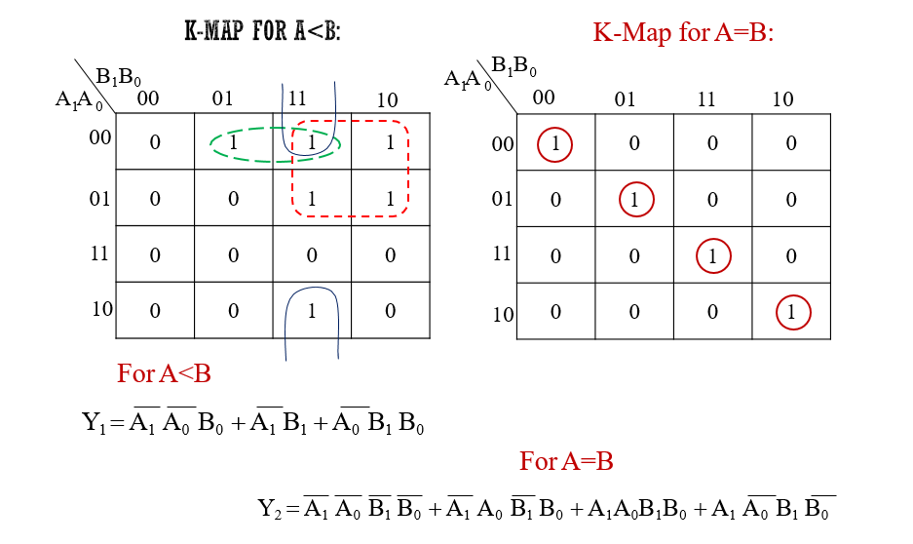

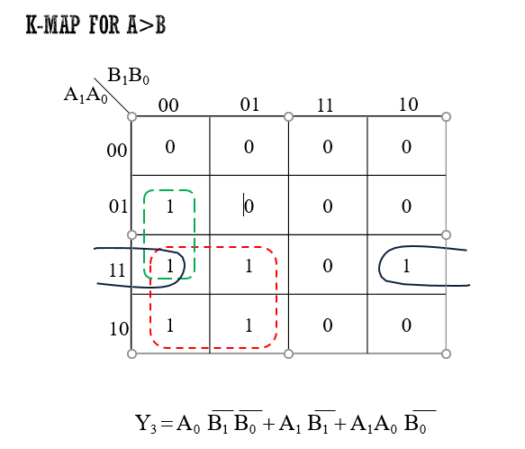

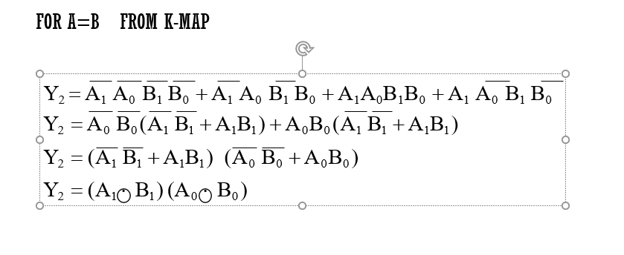

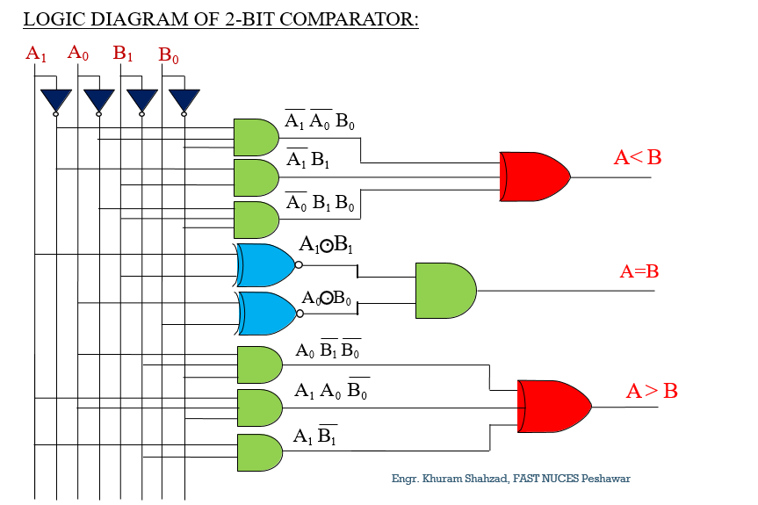

How to design a 4–bit comparator?
The truth table for a 4-bit comparator would have 4^4 = 256 rows. So we will do things a bit differently here. We will compare each bit of the two 4-bit numbers, and based on that comparison and the weight of their positions, we will draft a truth table.
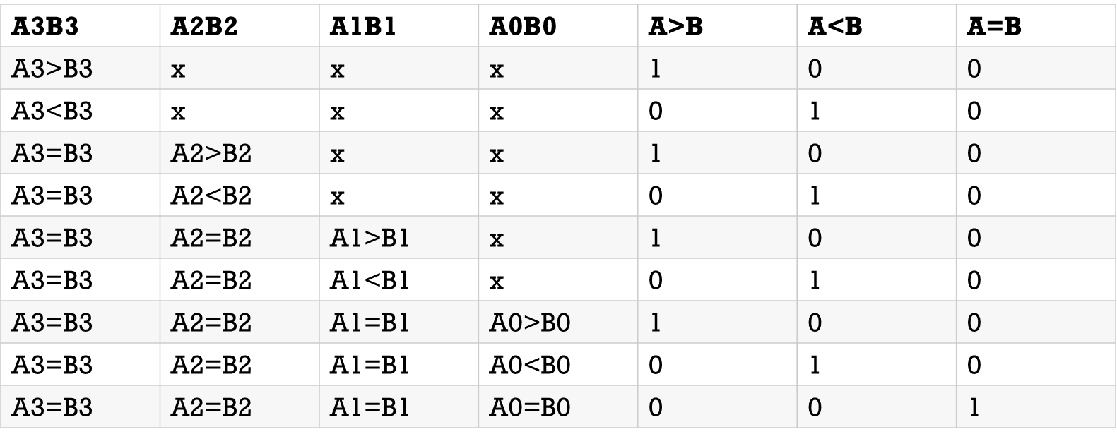

- In a 4-bit comparator the condition of A>B can be possible in the following four cases:

If A3 = 1 and B3 = 0
If A3 = B3 and A2 = 1 and B2 = 0
If A3 = B3, A2 = B2 and A1 = 1 and B1 = 0
If A3 = B3, A2 = B2, A1 = B1 and A0 = 1 and B0 = 0
- Similarly the condition for A<B can be possible in the following four cases:
If A3 = 0 and B3 = 1
If A3 = B3 and A2 = 0 and B2 = 1
If A3 = B3, A2 = B2 and A1 = 0 and B1 = 1
If A3 = B3, A2 = B2, A1 = B1 and A0 = 0 and B0 = 1
- The condition of A=B is possible only when all the individual bits of one number exactly coincide with corresponding bits of another number.
- A=B: (A3 Ex-Nor B3) (A2 Ex-Nor 82) (Al Ex-Nor BI) (AO Ex-Nor BO)

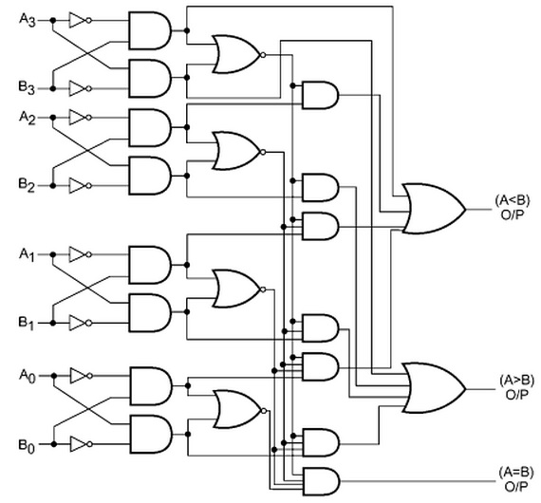

Applications of Comparators

- These are used in the address decoding circuitry in computers and microprocessor based devices to select a specific input/output device for the storage of data.
- These are used in control applications in which the binary numbers representing physical variables such as temperature, position, etc. are compared with a reference value. Then the outputs from the comparator are used to drive the actuators so as to make the physical variables closest to the set or reference value.
- Process controllers
- Servo-motor control
- Used in password verification and biometric applications.

Code converters
- The Code converter is used to convert one type of binary code to another.
- There are different types of binary codes like BCD code, gray code, excess-3 code, etc. Different codes are used for different types of digital applications.
- To get the required code from any one type of code, the simple code conversion process is done with the help of combinational circuits.
- A code converter circuit will convert coded information in one form to a different coding form.

BCD, Excess-3 code

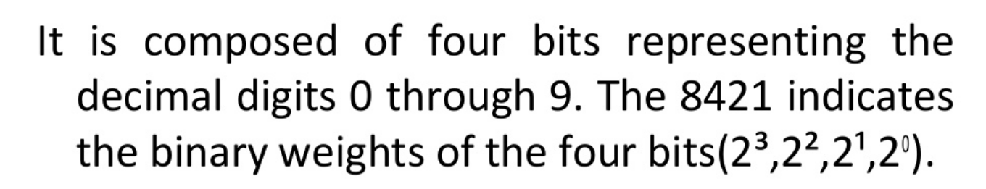

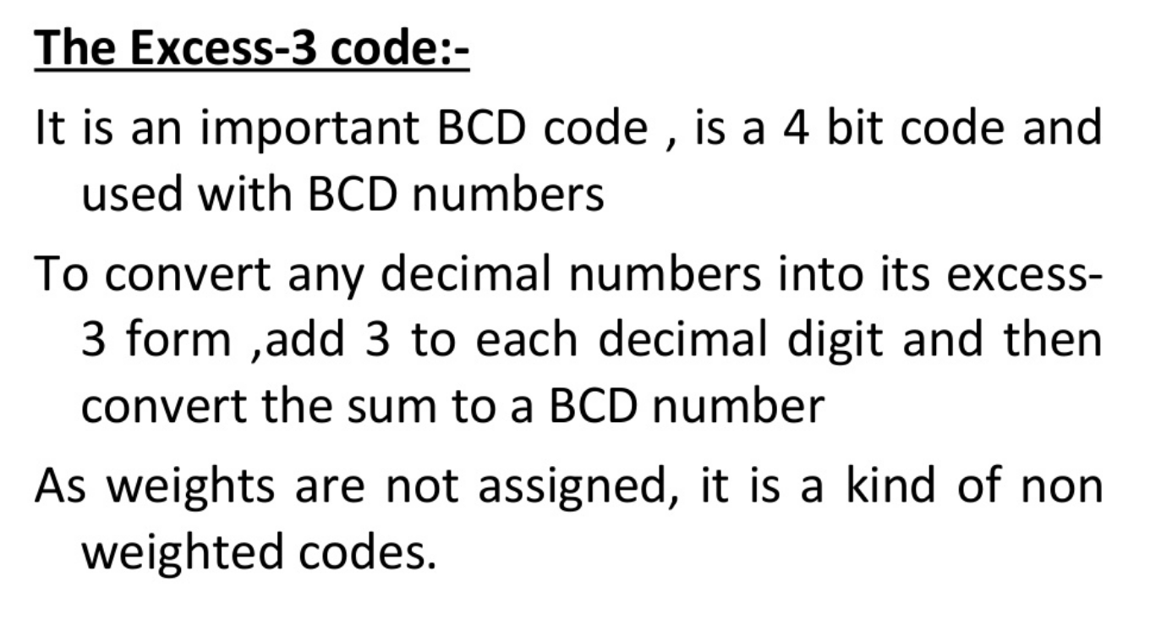

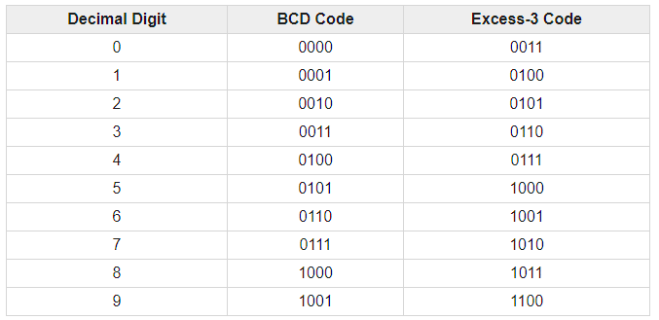

Binary, BCD, Excess-3 code
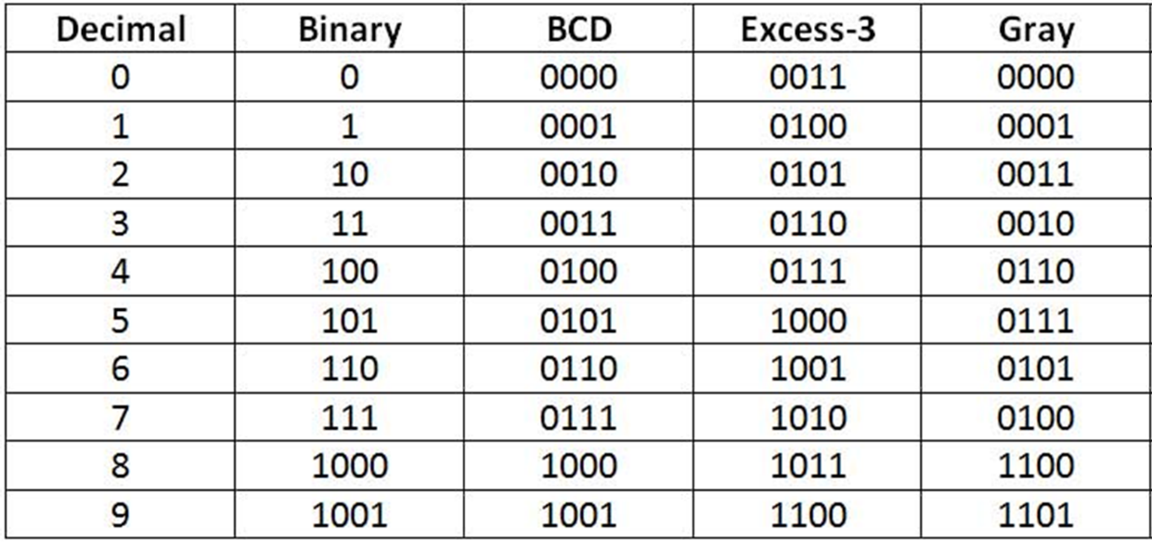
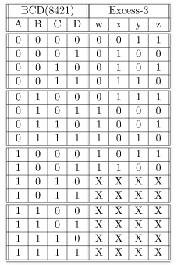
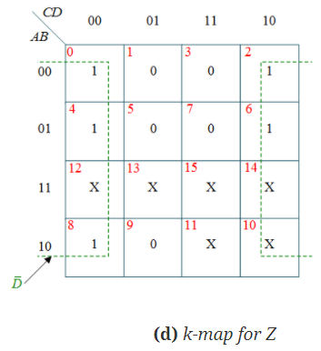
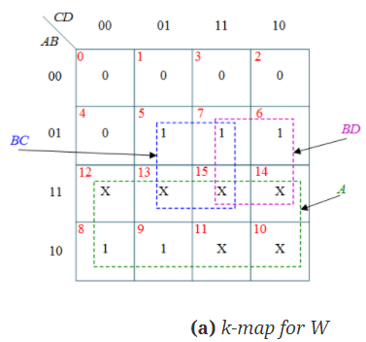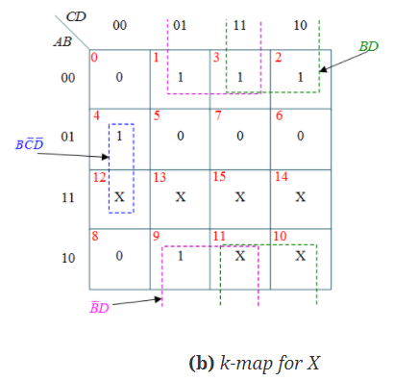
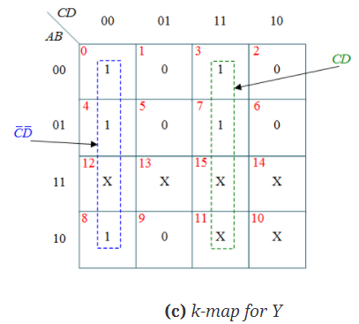

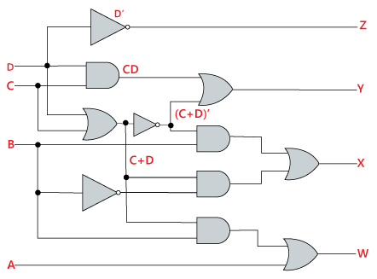

Students Task
- Implement 1 bit, 2 bit and 4 bit comparator on logic lay
- Implement Excess 3 Converter circuit on on logic ly
- Design K-map and circuit diagram for Gray Code like Excess 3

